Python Project - Hangman (Word Guess Game)
Name : Nikilesh Prakash V
Reg No : 411625149029
Department : BE CSE (Cybersecurity)
Subject : Python Project Batch : 04
UNIT – 05 Project: Hangman (Word Guess Game) Using Python
AIM:
To develop a simple word guessing game using Python where the player guesses letters of a hidden word within limited attempts.
Procedure:
1.Start the program and import the required module random.
2.Create a collection (list) of words that will be used in the game.
3.Select one word randomly using random.choice().
4.Initialize variables:
  - A list to store correctly guessed letters
  - Number of attempts (for example: 6)
5.Display a welcome message with game instructions.
6.Use a loop to run the game until the player wins or loses.
7.Inside the loop:
  - Show the current progress of the word using _ for missing letters
  - Display remaining attempts
8.Ask the user to enter a letter.
9.Validate the input:
  - Must be a single alphabet
  - Should not be already guessed
10.If the guess is correct:
  - Add it to the guessed list
  - Reveal it in the word display
11.If the guess is wrong:
  - Reduce the number of attempts
12.Check if all letters are guessed:
  - If yes, display winning message
13.If attempts become zero:
  - Display losing message and reveal the word
14.End the program.
CODE:
import random

print("🎯 Welcome to Word Guess Game!")

# word list
word_list = ["python", "cyber", "security", "network", "hacker", "coding"]

# select random word
secret_word = random.choice(word_list)

guessed = []
attempts = 6

# function to show word
def show_word():
result = ""
for ch in secret_word:
if ch in guessed:
result += ch + " "
else:
result += "_ "
return result

# game loop
while attempts > 0:
print("\nWord:", show_word())
print("Remaining Attempts:", attempts)

user_input = input("Guess a letter: ").lower()

# validation
if len(user_input) != 1 or not user_input.isalpha():
print("❌ Please enter a single alphabet only!")
continue

if user_input in guessed:
print("⚠ Already guessed!")
continue

guessed.append(user_input)

if user_input in secret_word:
print("✅ Good guess!")
else:
print("❌ Incorrect!")
attempts -= 1

# win condition
if all(letter in guessed for letter in secret_word):
print("\n🎉 Congratulations! You guessed the word:", secret_word)
break

# lose condition
if attempts == 0:
print("\n💀 Game Over!")
print("Correct word was:", secret_word)

OUTPUT:
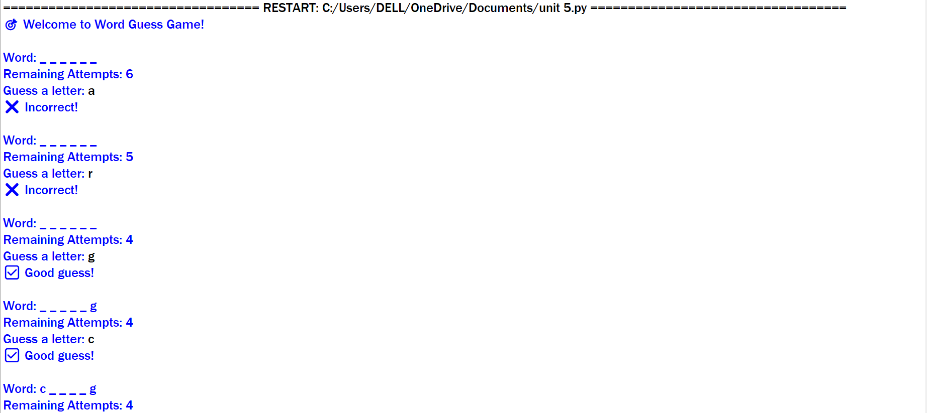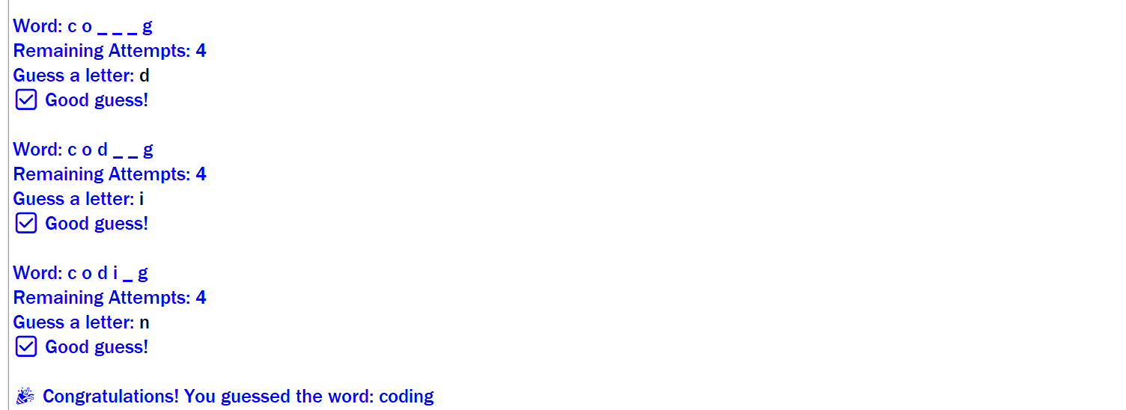

RESULT:

The Hangman (Word Guess) game was successfully implemented using Python. The program randomly selects a word, allows the user to guess letters within limited attempts, and displays the progress after each guess. It effectively validates inputs and correctly determines the win or loss condition.

